**Cryptography & Network Security**

**PRN - 2019BTECS00026**

**Name - Niraja Vasudev Kulkarni**

**Batch - B1**

**Assignment - 11**

**Title:** Diffie-Hellman Key Exchange

**Aim**: To Demonstrate Diffie-Hellman Key Exchange

**Theory:**

Diffie–Hellman key exchange is a method of securely exchanging cryptographic keys over a public channel and was one of the first public-key protocols as conceived by Ralph Merkle and named after Whitfield Diffie and Martin Hellman.

**Code:**

**Client -**

import socket

import os

def power(a,b,P):

    if (b == 1):

        return a

    else:

        return ((pow(a, b)) % P)

print("************CLIENT PROGRAM STARTED ******************")

s=socket.socket()

host=socket.gethostname() #server hostname

#host='127.0.0.1'

port=12000 #same as server

s.connect((host,port))

print("Connected to : ",host,port)

# fileToSend = open("ToSend.txt","r")

# content = fileToSend.read()

P = 941

q = 627

b = int(input('Enter Your private Key: '))

y = power(q , b, P)

s.send(str(y).encode())

x = int(s.recv(100).decode())

kb = power(x, b, P);

print('Secret Key of Bob: ' ,kb)

print("************CLIENT PROGRAM ENDED ******************")

**Server -**

import socket

import os

import sys

def power(a,b,P):

    if (b == 1):

        return a

    else:

        return ((pow(a, b)) % P)

print("***SERVER PROGRAM STARTED ****")

s=socket.socket()

host=socket.gethostname()

#host='127.0.0.1'

port=12000 #ports after 6000 are free

s.bind((host,port))

s.listen(10)

P = 941

q = 627

while True:

    c,addr=s.accept()

    print ("Client connected",addr)

    print ('Got Connection from' ,addr)

    a = int(input('Enter Your private Key: '))

    x = power(q , a, P)

    y=int(c.recv(100).decode())

    if not y:

        break

    c.send(str(x).encode())

    ka = power(y, a, P); #Secret key for Alice

    print('Secret Key of Alice: ', ka)

    break

print("***SERVER PROGRAM ENDED ****")

**Output:**

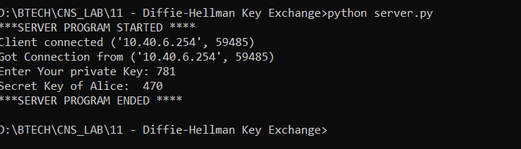

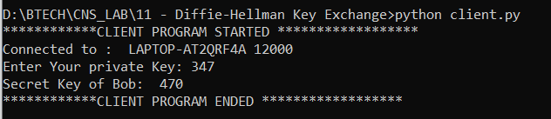

**Conclusion:**

The Diffie–Hellman key exchange method allows two parties that have no prior knowledge of each other to jointly establish a shared secret key over an insecure channel. This key can then be used to encrypt subsequent communications using a symmetric-key cipher.